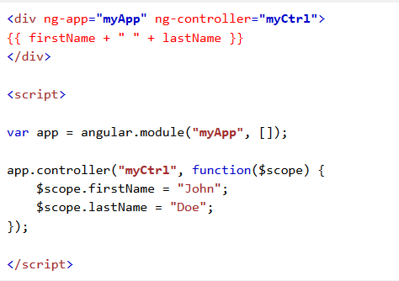

**AngularJS Extends HTML**

AngularJS extends HTML with ng-directives.

The **ng-app** directive defines an AngularJS application.

* The **ng-app** directive tells AngularJS that the <div> element is the "owner" of an AngularJS application.

The **ng-model** directive binds the value of HTML controls (input, select, textarea) to application data.

* The **ng-model** directive binds the value of the input field to the application variable name.

The **ng-bind** directive binds application data to the HTML view.

* The **ng-bind** directive binds the innerHTML of the <p> element to the application variable name.

**AngularJS Applications**

AngularJS modules define AngularJS applications.

AngularJS controllers control AngularJS applications.

The ng-app directive defines the application, the ng-controller directive defines the controller.

**An AngularJS module defines an application.**

The **module** is a container for the different parts of an application.

The **module** is a container for the application controllers.

**Controllers** always belong to a **module**.